**EVENT DRIVEN PROGRAMING**

**COLLINS MUTHOMI J17-1377-2022**

**Question 1**

**/\***

**\* To change this license header, choose License Headers in Project Properties.**

**\* To change this template file, choose Tools | Templates**

**\* and open the template in the editor.**

**\*/**

**package loginform;**

**import java.sql.Connection;**

**import java.sql.DriverManager;**

**import java.sql.PreparedStatement;**

**import java.sql.ResultSet;**

**import java.sql.SQLException;**

**import java.util.Vector;**

**import java.util.logging.Level;**

**import java.util.logging.Logger;**

**import javax.swing.DefaultListModel;**

**/\*\***

**\***

**\* @author colloh**

**\*/**

**public class NewJFrame extends javax.swing.JFrame {**

**/\*\***

**\* Creates new form NewJFrame**

**\*/**

**public NewJFrame() {**

**initComponents();**

**jButton1.setEnabled(false);**

**getdata();**

**}**

**/\*\***

**\* This method is called from within the constructor to initialize the form.**

**\* WARNING: Do NOT modify this code. The content of this method is always**

**\* regenerated by the Form Editor.**

**\*/**

**@SuppressWarnings("unchecked")**

**// <editor-fold defaultstate="collapsed" desc="Generated Code">**

**private void initComponents() {**

**buttonGroup1 = new javax.swing.ButtonGroup();**

**jLabel1 = new javax.swing.JLabel();**

**jLabel2 = new javax.swing.JLabel();**

**jLabel3 = new javax.swing.JLabel();**

**jLabel4 = new javax.swing.JLabel();**

**jLabel5 = new javax.swing.JLabel();**

**jCheckBox1 = new javax.swing.JCheckBox();**

**jButton1 = new javax.swing.JButton();**

**jButton2 = new javax.swing.JButton();**

**jTextField1 = new javax.swing.JTextField();**

**jTextField2 = new javax.swing.JTextField();**

**jTextField3 = new javax.swing.JTextField();**

**jPanel1 = new javax.swing.JPanel();**

**jRadioButton1 = new javax.swing.JRadioButton();**

**jRadioButton2 = new javax.swing.JRadioButton();**

**jComboBox1 = new javax.swing.JComboBox();**

**jComboBox2 = new javax.swing.JComboBox();**

**jComboBox3 = new javax.swing.JComboBox();**

**jScrollPane1 = new javax.swing.JScrollPane();**

**jList1 = new javax.swing.JList();**

**setDefaultCloseOperation(javax.swing.WindowConstants.EXIT_ON_CLOSE);**

**jLabel1.setText("Name");**

**jLabel2.setText("mobile");**

**jLabel3.setText("gender");**

**jLabel4.setText("DOB");**

**jLabel5.setText("Address");**

**jCheckBox1.setText("Accept term and conditions");**

**jCheckBox1.addActionListener(new java.awt.event.ActionListener() {**

**public void actionPerformed(java.awt.event.ActionEvent evt) {**

**jCheckBox1ActionPerformed(evt);**

**}**

**});**

**jButton1.setText("submit");**

**jButton1.addActionListener(new java.awt.event.ActionListener() {**

**public void actionPerformed(java.awt.event.ActionEvent evt) {**

**jButton1ActionPerformed(evt);**

**}**

**});**

**jButton2.setText("Reset");**

**jButton2.addActionListener(new java.awt.event.ActionListener() {**

**public void actionPerformed(java.awt.event.ActionEvent evt) {**

**jButton2ActionPerformed(evt);**

**}**

**});**

**buttonGroup1.add(jRadioButton1);**

**jRadioButton1.setText("Male");**

**buttonGroup1.add(jRadioButton2);**

**jRadioButton2.setText("Female");**

**javax.swing.GroupLayout jPanel1Layout = new javax.swing.GroupLayout(jPanel1);**

**jPanel1.setLayout(jPanel1Layout);**

**jPanel1Layout.setHorizontalGroup(**

**jPanel1Layout.createParallelGroup(javax.swing.GroupLayout.Alignment.LEADING)**

**.addGroup(jPanel1Layout.createSequentialGroup()**

**.addComponent(jRadioButton1)**

**.addGap(31, 31, 31)**

**.addComponent(jRadioButton2)**

**.addContainerGap(javax.swing.GroupLayout.DEFAULT_SIZE, Short.MAX_VALUE))**

**);**

**jPanel1Layout.setVerticalGroup(**

**jPanel1Layout.createParallelGroup(javax.swing.GroupLayout.Alignment.LEADING)**

**.addGroup(jPanel1Layout.createSequentialGroup()**

**.addGroup(jPanel1Layout.createParallelGroup(javax.swing.GroupLayout.Alignment.BASELINE)**

**.addComponent(jRadioButton1)**

**.addComponent(jRadioButton2))**

**.addGap(0, 0, Short.MAX_VALUE))**

**);**

**jComboBox1.setModel(new javax.swing.DefaultComboBoxModel(new String[] { "Date", "1", "2", "3", "4", "5", "6", "7", "8", "9", "10", "11", "12", "13", "14", "15", "16", "17", "18", "19", "20", "21", "22", "23", "24", "25", "26", "27", "28", "29", "30", "31" }));**

**jComboBox2.setModel(new javax.swing.DefaultComboBoxModel(new String[] { "Month", "jan", "feb", "mar", "apr", "may", "june", "july", "aug", "sep", "oct", "nov", "dec" }));**

**jComboBox3.setModel(new javax.swing.DefaultComboBoxModel(new String[] { "Year", "2000", "2001", "20003", "2004", "2005", "2006", "2007", "2008", "2009", "2010", "2011", "2012", " " }));**

**jScrollPane1.setViewportView(jList1);**

**javax.swing.GroupLayout layout = new javax.swing.GroupLayout(getContentPane());**

**getContentPane().setLayout(layout);**

**layout.setHorizontalGroup(**

**layout.createParallelGroup(javax.swing.GroupLayout.Alignment.LEADING)**

**.addGroup(layout.createSequentialGroup()**

**.addGap(27, 27, 27)**

**.addGroup(layout.createParallelGroup(javax.swing.GroupLayout.Alignment.LEADING)**

**.addGroup(layout.createSequentialGroup()**

**.addComponent(jLabel5)**

**.addPreferredGap(javax.swing.LayoutStyle.ComponentPlacement.UNRELATED)**

**.addComponent(jTextField3, javax.swing.GroupLayout.PREFERRED_SIZE, 152, javax.swing.GroupLayout.PREFERRED_SIZE))**

**.addGroup(layout.createSequentialGroup()**

**.addGroup(layout.createParallelGroup(javax.swing.GroupLayout.Alignment.LEADING)**

**.addComponent(jLabel3)**

**.addComponent(jLabel4))**

**.addGap(18, 18, 18)**

**.addGroup(layout.createParallelGroup(javax.swing.GroupLayout.Alignment.LEADING, false)**

**.addGroup(layout.createSequentialGroup()**

**.addComponent(jComboBox1, javax.swing.GroupLayout.PREFERRED_SIZE, javax.swing.GroupLayout.DEFAULT_SIZE, javax.swing.GroupLayout.PREFERRED_SIZE)**

**.addPreferredGap(javax.swing.LayoutStyle.ComponentPlacement.RELATED)**

**.addComponent(jComboBox2, javax.swing.GroupLayout.PREFERRED_SIZE, javax.swing.GroupLayout.DEFAULT_SIZE, javax.swing.GroupLayout.PREFERRED_SIZE)**

**.addPreferredGap(javax.swing.LayoutStyle.ComponentPlacement.RELATED)**

**.addComponent(jComboBox3, javax.swing.GroupLayout.PREFERRED_SIZE, javax.swing.GroupLayout.DEFAULT_SIZE, javax.swing.GroupLayout.PREFERRED_SIZE))**

**.addComponent(jPanel1, javax.swing.GroupLayout.DEFAULT_SIZE, javax.swing.GroupLayout.DEFAULT_SIZE, Short.MAX_VALUE)))**

**.addGroup(layout.createParallelGroup(javax.swing.GroupLayout.Alignment.LEADING, false)**

**.addGroup(layout.createSequentialGroup()**

**.addComponent(jLabel2)**

**.addGap(18, 18, 18)**

**.addComponent(jTextField2))**

**.addGroup(layout.createSequentialGroup()**

**.addComponent(jLabel1)**

**.addGap(18, 18, 18)**

**.addComponent(jTextField1, javax.swing.GroupLayout.PREFERRED_SIZE, 156, javax.swing.GroupLayout.PREFERRED_SIZE))**

**.addGroup(layout.createSequentialGroup()**

**.addGap(49, 49, 49)**

**.addComponent(jButton1)**

**.addGap(18, 18, 18)**

**.addComponent(jButton2)))**

**.addGroup(layout.createSequentialGroup()**

**.addGap(36, 36, 36)**

**.addComponent(jCheckBox1)))**

**.addPreferredGap(javax.swing.LayoutStyle.ComponentPlacement.RELATED)**

**.addComponent(jScrollPane1, javax.swing.GroupLayout.DEFAULT_SIZE, 292, Short.MAX_VALUE))**

**);**

**layout.setVerticalGroup(**

**layout.createParallelGroup(javax.swing.GroupLayout.Alignment.LEADING)**

**.addGroup(layout.createSequentialGroup()**

**.addGap(13, 13, 13)**

**.addGroup(layout.createParallelGroup(javax.swing.GroupLayout.Alignment.BASELINE)**

**.addComponent(jLabel1)**

**.addComponent(jTextField1, javax.swing.GroupLayout.PREFERRED_SIZE, javax.swing.GroupLayout.DEFAULT_SIZE, javax.swing.GroupLayout.PREFERRED_SIZE))**

**.addPreferredGap(javax.swing.LayoutStyle.ComponentPlacement.UNRELATED)**

**.addGroup(layout.createParallelGroup(javax.swing.GroupLayout.Alignment.BASELINE)**

**.addComponent(jLabel2)**

**.addComponent(jTextField2, javax.swing.GroupLayout.PREFERRED_SIZE, javax.swing.GroupLayout.DEFAULT_SIZE, javax.swing.GroupLayout.PREFERRED_SIZE))**

**.addPreferredGap(javax.swing.LayoutStyle.ComponentPlacement.UNRELATED)**

**.addGroup(layout.createParallelGroup(javax.swing.GroupLayout.Alignment.LEADING)**

**.addComponent(jLabel3)**

**.addComponent(jPanel1, javax.swing.GroupLayout.PREFERRED_SIZE, javax.swing.GroupLayout.DEFAULT_SIZE, javax.swing.GroupLayout.PREFERRED_SIZE))**

**.addPreferredGap(javax.swing.LayoutStyle.ComponentPlacement.RELATED)**

**.addGroup(layout.createParallelGroup(javax.swing.GroupLayout.Alignment.BASELINE)**

**.addComponent(jLabel4)**

**.addComponent(jComboBox1, javax.swing.GroupLayout.PREFERRED_SIZE, javax.swing.GroupLayout.DEFAULT_SIZE, javax.swing.GroupLayout.PREFERRED_SIZE)**

**.addComponent(jComboBox2, javax.swing.GroupLayout.PREFERRED_SIZE, javax.swing.GroupLayout.DEFAULT_SIZE, javax.swing.GroupLayout.PREFERRED_SIZE)**

**.addComponent(jComboBox3, javax.swing.GroupLayout.PREFERRED_SIZE, javax.swing.GroupLayout.DEFAULT_SIZE, javax.swing.GroupLayout.PREFERRED_SIZE))**

**.addGap(12, 12, 12)**

**.addComponent(jCheckBox1)**

**.addGap(18, 18, 18)**

**.addGroup(layout.createParallelGroup(javax.swing.GroupLayout.Alignment.BASELINE)**

**.addComponent(jLabel5)**

**.addComponent(jTextField3, javax.swing.GroupLayout.PREFERRED_SIZE, javax.swing.GroupLayout.DEFAULT_SIZE, javax.swing.GroupLayout.PREFERRED_SIZE))**

**.addGap(18, 18, 18)**

**.addGroup(layout.createParallelGroup(javax.swing.GroupLayout.Alignment.BASELINE)**

**.addComponent(jButton1)**

**.addComponent(jButton2))**

**.addContainerGap(62, Short.MAX_VALUE))**

**.addGroup(javax.swing.GroupLayout.Alignment.TRAILING, layout.createSequentialGroup()**

**.addContainerGap(javax.swing.GroupLayout.DEFAULT_SIZE, Short.MAX_VALUE)**

**.addComponent(jScrollPane1, javax.swing.GroupLayout.PREFERRED_SIZE, 218, javax.swing.GroupLayout.PREFERRED_SIZE)**

**.addContainerGap(javax.swing.GroupLayout.DEFAULT_SIZE, Short.MAX_VALUE))**

**);**

**pack();**

**}// </editor-fold>**

**private void jCheckBox1ActionPerformed(java.awt.event.ActionEvent evt) {**

**if (jCheckBox1.isSelected()) {**

**jButton1.setEnabled(true);**

**} else {**

**jButton1.setEnabled(false);**

**}**

**// TODO add your handling code here:**

**}**

**private void jButton1ActionPerformed(java.awt.event.ActionEvent evt) {**

**try {**

**String Name = jTextField1.getText();**

**int Mobile = Integer.parseInt(jTextField2.getText());**

**String gender;**

**if (jRadioButton1.isSelected()) {**

**gender = jRadioButton1.getText();**

**} else {**

**gender = jRadioButton1.getText();**

**};**

**String Dob;**

**String Date = jComboBox1.getSelectedItem().toString();**

**String month = jComboBox2.getSelectedItem().toString();**

**String year = jComboBox3.getSelectedItem().toString();**

**Dob = Date + " /" + month + "/" + year;**

**String address = jTextField2.getText();**

**Class.forName("com.mysql.jdbc.Driver");**

**Connection connector = DriverManager.getConnection("jdbc:mysql://localhost:3306/login1", "root", "");**

**PreparedStatement pst = connector.prepareStatement("insert into registration(name,mobile,gender,dob,address)value(?,?,?,?,?)");**

**pst.setString(1, Name);**

**pst.setInt(2, Mobile);**

**pst.setString(3, gender);**

**pst.setString(4, Dob);**

**pst.setString(5, address);**

**pst.executeUpdate();**

**System.out.println("Update successfull!!");**

**getdata();**

**} catch (Exception ex) {**

**Logger.getLogger(NewJFrame.class.getName()).log(Level.SEVERE, null, ex);**

**}**

**// TODO add your handling code here:**

**}**

**private void jButton2ActionPerformed(java.awt.event.ActionEvent evt) {**

**jTextField1.setText("");**

**jTextField2.setText("");**

**jTextField3.setText("");**

**buttonGroup1.clearSelection();**

**jCheckBox1.setSelected(false);**

**jComboBox1.setSelectedIndex(0);**

**jComboBox2.setSelectedIndex(0);**

**jComboBox3.setSelectedIndex(0);**

**}**

**/\*\***

**\* @param args the command line arguments**

**\*/**

**public static void main(String args[]) {**

**/* Set the Nimbus look and feel */**

**//<editor-fold defaultstate="collapsed" desc=" Look and feel setting code (optional) ">**

**/* If Nimbus (introduced in Java SE 6) is not available, stay with the default look and feel.**

**\* For details see http://download.oracle.com/javase/tutorial/uiswing/lookandfeel/plaf.html**

**\*/**

**try {**

**for (javax.swing.UIManager.LookAndFeelInfo info : javax.swing.UIManager.getInstalledLookAndFeels()) {**

**if ("Nimbus".equals(info.getName())) {**

**javax.swing.UIManager.setLookAndFeel(info.getClassName());**

**break;**

**}**

**}**

**} catch (ClassNotFoundException ex) {**

**java.util.logging.Logger.getLogger(NewJFrame.class.getName()).log(java.util.logging.Level.SEVERE, null, ex);**

**} catch (InstantiationException ex) {**

**java.util.logging.Logger.getLogger(NewJFrame.class.getName()).log(java.util.logging.Level.SEVERE, null, ex);**

**} catch (IllegalAccessException ex) {**

**java.util.logging.Logger.getLogger(NewJFrame.class.getName()).log(java.util.logging.Level.SEVERE, null, ex);**

**} catch (javax.swing.UnsupportedLookAndFeelException ex) {**

**java.util.logging.Logger.getLogger(NewJFrame.class.getName()).log(java.util.logging.Level.SEVERE, null, ex);**

**}**

**//</editor-fold>**

**/* Create and display the form */**

**java.awt.EventQueue.invokeLater(new Runnable() {**

**public void run() {**

**new NewJFrame().setVisible(true);**

**}**

**});**

**}**

**// Variables declaration - do not modify**

**private javax.swing.ButtonGroup buttonGroup1;**

**private javax.swing.JButton jButton1;**

**private javax.swing.JButton jButton2;**

**private javax.swing.JCheckBox jCheckBox1;**

**private javax.swing.JComboBox jComboBox1;**

**private javax.swing.JComboBox jComboBox2;**

**private javax.swing.JComboBox jComboBox3;**

**private javax.swing.JLabel jLabel1;**

**private javax.swing.JLabel jLabel2;**

**private javax.swing.JLabel jLabel3;**

**private javax.swing.JLabel jLabel4;**

**private javax.swing.JLabel jLabel5;**

**private javax.swing.JList jList1;**

**private javax.swing.JPanel jPanel1;**

**private javax.swing.JRadioButton jRadioButton1;**

**private javax.swing.JRadioButton jRadioButton2;**

**private javax.swing.JScrollPane jScrollPane1;**

**private javax.swing.JTextField jTextField1;**

**private javax.swing.JTextField jTextField2;**

**private javax.swing.JTextField jTextField3;**

**// End of variables declaration**

**private void getdata() {**

**try {**

**Connection connector = DriverManager.getConnection("jdbc:mysql://localhost:3306/login1", "root", "");**

**PreparedStatement statement = connector.prepareStatement("SELECT * FROM `registration`");**

**ResultSet result = statement.executeQuery();**

**//DefaultListModel model = new DefaultListModel();**

**Vector<String> dataVector = new Vector<>();**

**while (result.next()) {**

**String name = result.getString("name");**

**int mobile = result.getInt("mobile");**

**String gender = result.getString("gender");**

**String dob = result.getString("dob");**

**String address = result.getString("address");**

**dataVector.add("Name :" + name + "| Mobile: " + mobile+"|gender:"+ gender + "dob" + dob**

**+ "address:" + address**

**);**

**}**

**jList1.setListData(dataVector);**

**result.close();**

**statement.close();**

**connector.close();**

**} catch (SQLException ex) {**

**Logger.getLogger(NewJFrame.class.getName()).log(Level.SEVERE, null, ex);**

**}**

**}**

**}**

**1**



**END OF QUESTION FORM LOGIN 1**

**EVENT DRIVEN DRIVEN QUESTION 2**

**/\***

**\* To change this license header, choose License Headers in Project Properties.**

**\* To change this template file, choose Tools | Templates**

**\* and open the template in the editor.**

**\*/**

**package registration.form2;**

**import java.sql.Array;**

**import java.sql.Connection;**

**import java.sql.DriverManager;**

**import java.sql.PreparedStatement;**

**import java.sql.ResultSet;**

**import java.sql.ResultSetMetaData;**

**import java.sql.SQLException;**

**import java.util.Vector;**

**import java.util.logging.Level;**

**import java.util.logging.Logger;**

**import javax.swing.table.DefaultTableModel;**

**/\*\***

**\***

**\* @author colloh**

**\*/**

**public class NewJFrame extends javax.swing.JFrame {**

**private Object jOptionPane;**

**/\*\***

**\* Creates new form NewJFrame**

**\*/**

**public NewJFrame() {**

**initComponents();**

**getdata();**

**}**

**/\*\***

**\* This method is called from within the constructor to initialize the form.**

**\* WARNING: Do NOT modify this code. The content of this method is always**

**\* regenerated by the Form Editor.**

**\*/**

**@SuppressWarnings("unchecked")**

**// <editor-fold defaultstate="collapsed" desc="Generated Code">**

**private void initComponents() {**

**buttonGroup1 = new javax.swing.ButtonGroup();**

**jScrollPane2 = new javax.swing.JScrollPane();**

**jTable2 = new javax.swing.JTable();**

**buttonGroup2 = new javax.swing.ButtonGroup();**

**jLabel1 = new javax.swing.JLabel();**

**jLabel2 = new javax.swing.JLabel();**

**jLabel3 = new javax.swing.JLabel();**

**jLabel4 = new javax.swing.JLabel();**

**jLabel5 = new javax.swing.JLabel();**

**jButton1 = new javax.swing.JButton();**

**jButton2 = new javax.swing.JButton();**

**jTextField1 = new javax.swing.JTextField();**

**jTextField2 = new javax.swing.JTextField();**

**jTextField3 = new javax.swing.JTextField();**

**jTextField4 = new javax.swing.JTextField();**

**jPanel1 = new javax.swing.JPanel();**

**jRadioButton1 = new javax.swing.JRadioButton();**

**jRadioButton2 = new javax.swing.JRadioButton();**

**jScrollPane1 = new javax.swing.JScrollPane();**

**jTable1 = new javax.swing.JTable();**

**jTable2.setModel(new javax.swing.table.DefaultTableModel(**

**new Object [][] {**

**{null, null, null, null},**

**{null, null, null, null},**

**{null, null, null, null},**

**{null, null, null, null}**

**},**

**new String [] {**

**"Title 1", "Title 2", "Title 3", "Title 4"**

**}**

**));**

**jScrollPane2.setViewportView(jTable2);**

**setDefaultCloseOperation(javax.swing.WindowConstants.EXIT_ON_CLOSE);**

**jLabel1.setText("ID");**

**jLabel2.setText("Name");**

**jLabel3.setText("Gender");**

**jLabel4.setText("Address");**

**jLabel5.setText("Contact");**

**jButton1.setText("Exit");**

**jButton1.addActionListener(new java.awt.event.ActionListener() {**

**public void actionPerformed(java.awt.event.ActionEvent evt) {**

**jButton1ActionPerformed(evt);**

**}**

**});**

**jButton2.setText("Register");**

**jButton2.addActionListener(new java.awt.event.ActionListener() {**

**public void actionPerformed(java.awt.event.ActionEvent evt) {**

**jButton2ActionPerformed(evt);**

**}**

**});**

**buttonGroup1.add(jRadioButton1);**

**jRadioButton1.setText("Male");**

**buttonGroup1.add(jRadioButton2);**

**jRadioButton2.setText("Female");**

**javax.swing.GroupLayout jPanel1Layout = new javax.swing.GroupLayout(jPanel1);**

**jPanel1.setLayout(jPanel1Layout);**

**jPanel1Layout.setHorizontalGroup(**

**jPanel1Layout.createParallelGroup(javax.swing.GroupLayout.Alignment.LEADING)**

**.addGroup(jPanel1Layout.createSequentialGroup()**

**.addContainerGap()**

**.addComponent(jRadioButton1)**

**.addPreferredGap(javax.swing.LayoutStyle.ComponentPlacement.RELATED, 30, Short.MAX_VALUE)**

**.addComponent(jRadioButton2)**

**.addGap(18, 18, 18))**

**);**

**jPanel1Layout.setVerticalGroup(**

**jPanel1Layout.createParallelGroup(javax.swing.GroupLayout.Alignment.LEADING)**

**.addGroup(javax.swing.GroupLayout.Alignment.TRAILING, jPanel1Layout.createSequentialGroup()**

**.addGroup(jPanel1Layout.createParallelGroup(javax.swing.GroupLayout.Alignment.BASELINE)**

**.addComponent(jRadioButton1)**

**.addComponent(jRadioButton2))**

**.addGap(0, 0, Short.MAX_VALUE))**

**);**

**jTable1.setModel(new javax.swing.table.DefaultTableModel(**

**new Object [][] {**

**{null, null, null, null, null},**

**{null, null, null, null, null}**

**},**

**new String [] {**

**"ID", "Name", "Gender", "Address", "contact"**

**}**

**) {**

**Class[] types = new Class [] {**

**java.lang.Integer.class, java.lang.String.class, java.lang.String.class, java.lang.String.class, java.lang.Integer.class**

**};**

**public Class getColumnClass(int columnIndex) {**

**return types [columnIndex];**

**}**

**});**

**jScrollPane1.setViewportView(jTable1);**

**javax.swing.GroupLayout layout = new javax.swing.GroupLayout(getContentPane());**

**getContentPane().setLayout(layout);**

**layout.setHorizontalGroup(**

**layout.createParallelGroup(javax.swing.GroupLayout.Alignment.LEADING)**

**.addGroup(layout.createSequentialGroup()**

**.addGroup(layout.createParallelGroup(javax.swing.GroupLayout.Alignment.LEADING)**

**.addGroup(layout.createSequentialGroup()**

**.addContainerGap()**

**.addGroup(layout.createParallelGroup(javax.swing.GroupLayout.Alignment.LEADING)**

**.addComponent(jLabel5)**

**.addGroup(layout.createSequentialGroup()**

**.addGroup(layout.createParallelGroup(javax.swing.GroupLayout.Alignment.LEADING)**

**.addComponent(jLabel1)**

**.addComponent(jLabel2)**

**.addComponent(jLabel4)**

**.addComponent(jLabel3))**

**.addGap(22, 22, 22)**

**.addGroup(layout.createParallelGroup(javax.swing.GroupLayout.Alignment.LEADING)**

**.addGroup(layout.createParallelGroup(javax.swing.GroupLayout.Alignment.TRAILING, false)**

**.addComponent(jTextField4, javax.swing.GroupLayout.Alignment.LEADING, javax.swing.GroupLayout.DEFAULT_SIZE, 148, Short.MAX_VALUE)**

**.addComponent(jTextField3, javax.swing.GroupLayout.Alignment.LEADING))**

**.addComponent(jPanel1, javax.swing.GroupLayout.PREFERRED_SIZE, javax.swing.GroupLayout.DEFAULT_SIZE, javax.swing.GroupLayout.PREFERRED_SIZE)**

**.addGroup(layout.createParallelGroup(javax.swing.GroupLayout.Alignment.TRAILING, false)**

**.addComponent(jTextField1, javax.swing.GroupLayout.Alignment.LEADING, javax.swing.GroupLayout.DEFAULT_SIZE, 146, Short.MAX_VALUE)**

**.addComponent(jTextField2, javax.swing.GroupLayout.Alignment.LEADING))))))**

**.addGroup(layout.createSequentialGroup()**

**.addGap(33, 33, 33)**

**.addComponent(jButton1)**

**.addGap(31, 31, 31)**

**.addComponent(jButton2)))**

**.addPreferredGap(javax.swing.LayoutStyle.ComponentPlacement.RELATED, 32, Short.MAX_VALUE)**

**.addComponent(jScrollPane1, javax.swing.GroupLayout.PREFERRED_SIZE, 273, javax.swing.GroupLayout.PREFERRED_SIZE)**

**.addContainerGap())**

**);**

**layout.setVerticalGroup(**

**layout.createParallelGroup(javax.swing.GroupLayout.Alignment.LEADING)**

**.addGroup(layout.createSequentialGroup()**

**.addContainerGap()**

**.addGroup(layout.createParallelGroup(javax.swing.GroupLayout.Alignment.LEADING)**

**.addComponent(jLabel1)**

**.addComponent(jTextField1, javax.swing.GroupLayout.PREFERRED_SIZE, javax.swing.GroupLayout.DEFAULT_SIZE, javax.swing.GroupLayout.PREFERRED_SIZE))**

**.addGap(18, 18, 18)**

**.addGroup(layout.createParallelGroup(javax.swing.GroupLayout.Alignment.BASELINE)**

**.addComponent(jLabel2)**

**.addComponent(jTextField2, javax.swing.GroupLayout.PREFERRED_SIZE, javax.swing.GroupLayout.DEFAULT_SIZE, javax.swing.GroupLayout.PREFERRED_SIZE))**

**.addGap(9, 9, 9)**

**.addGroup(layout.createParallelGroup(javax.swing.GroupLayout.Alignment.LEADING)**

**.addComponent(jLabel3)**

**.addComponent(jPanel1, javax.swing.GroupLayout.PREFERRED_SIZE, 20, javax.swing.GroupLayout.PREFERRED_SIZE))**

**.addGap(6, 6, 6)**

**.addGroup(layout.createParallelGroup(javax.swing.GroupLayout.Alignment.BASELINE)**

**.addComponent(jLabel4)**

**.addComponent(jTextField3, javax.swing.GroupLayout.PREFERRED_SIZE, javax.swing.GroupLayout.DEFAULT_SIZE, javax.swing.GroupLayout.PREFERRED_SIZE))**

**.addGap(18, 18, 18)**

**.addGroup(layout.createParallelGroup(javax.swing.GroupLayout.Alignment.LEADING)**

**.addGroup(layout.createSequentialGroup()**

**.addComponent(jLabel5)**

**.addGap(53, 53, 53)**

**.addGroup(layout.createParallelGroup(javax.swing.GroupLayout.Alignment.BASELINE)**

**.addComponent(jButton1)**

**.addComponent(jButton2)))**

**.addComponent(jTextField4, javax.swing.GroupLayout.PREFERRED_SIZE, javax.swing.GroupLayout.DEFAULT_SIZE, javax.swing.GroupLayout.PREFERRED_SIZE))**

**.addContainerGap(javax.swing.GroupLayout.DEFAULT_SIZE, Short.MAX_VALUE))**

**.addGroup(javax.swing.GroupLayout.Alignment.TRAILING, layout.createSequentialGroup()**

**.addContainerGap(14, Short.MAX_VALUE)**

**.addComponent(jScrollPane1, javax.swing.GroupLayout.PREFERRED_SIZE, 275, javax.swing.GroupLayout.PREFERRED_SIZE)**

**.addContainerGap())**

**);**

**pack();**

**}// </editor-fold>**

**private void jButton1ActionPerformed(java.awt.event.ActionEvent evt) {**

**System.exit(0); // TODO add your handling code here:**

**}**

**private void jButton2ActionPerformed(java.awt.event.ActionEvent evt) {**

**try {**

**int ID = Integer.parseInt(jTextField1.getText());**

**String name = jTextField2.getText();**

**String Gender = "";**

**if (jRadioButton1.isSelected()) {**

**Gender = "male";**

**} else if (jRadioButton2.isSelected()) {**

**Gender = "female";**

**}**

**String Address = jTextField3.getText();**

**int Contact = Integer.parseInt(jTextField4.getText());**

**Class.forName("com.mysql.jdbc.Driver");**

**Connection registra = DriverManager.getConnection("jdbc:mysql://localhost:3306/registrationform2", "root", "");**

**PreparedStatement pst = registra.prepareStatement("insert into register(ID,name,Gender,address,contact)value(?,?,?,?,?)");**

**pst.setInt(1, ID);**

**pst.setString(2, name);**

**pst.setString(3, Gender);**

**pst.setString(4, Address);**

**pst.setInt(5, Contact);**

**pst.executeUpdate();**

**System.out.println("Update successfull!!");**

**getdata();**

**resetAfterUpdatedata();**

**} catch (Exception ex) {**

**Logger.getLogger(NewJFrame.class.getName()).log(Level.SEVERE, null, ex);**

**}**

**// TODO add your handling code here:**

**}**

**/\*\***

**\* @param args the command line arguments**

**\*/**

**public static void main(String args[]) {**

**/* Set the Nimbus look and feel */**

**//<editor-fold defaultstate="collapsed" desc=" Look and feel setting code (optional) ">**

**/* If Nimbus (introduced in Java SE 6) is not available, stay with the default look and feel.**

**\* For details see http://download.oracle.com/javase/tutorial/uiswing/lookandfeel/plaf.html**

**\*/**

**try {**

**for (javax.swing.UIManager.LookAndFeelInfo info : javax.swing.UIManager.getInstalledLookAndFeels()) {**

**if ("Nimbus".equals(info.getName())) {**

**javax.swing.UIManager.setLookAndFeel(info.getClassName());**

**break;**

**}**

**}**

**} catch (ClassNotFoundException ex) {**

**java.util.logging.Logger.getLogger(NewJFrame.class.getName()).log(java.util.logging.Level.SEVERE, null, ex);**

**} catch (InstantiationException ex) {**

**java.util.logging.Logger.getLogger(NewJFrame.class.getName()).log(java.util.logging.Level.SEVERE, null, ex);**

**} catch (IllegalAccessException ex) {**

**java.util.logging.Logger.getLogger(NewJFrame.class.getName()).log(java.util.logging.Level.SEVERE, null, ex);**

**} catch (javax.swing.UnsupportedLookAndFeelException ex) {**

**java.util.logging.Logger.getLogger(NewJFrame.class.getName()).log(java.util.logging.Level.SEVERE, null, ex);**

**}**

**//</editor-fold>**

**/* Create and display the form */**

**java.awt.EventQueue.invokeLater(new Runnable() {**

**public void run() {**

**new NewJFrame().setVisible(true);**

**}**

**});**

**}**

**// Variables declaration - do not modify**

**private javax.swing.ButtonGroup buttonGroup1;**

**private javax.swing.ButtonGroup buttonGroup2;**

**private javax.swing.JButton jButton1;**

**private javax.swing.JButton jButton2;**

**private javax.swing.JLabel jLabel1;**

**private javax.swing.JLabel jLabel2;**

**private javax.swing.JLabel jLabel3;**

**private javax.swing.JLabel jLabel4;**

**private javax.swing.JLabel jLabel5;**

**private javax.swing.JPanel jPanel1;**

**private javax.swing.JRadioButton jRadioButton1;**

**private javax.swing.JRadioButton jRadioButton2;**

**private javax.swing.JScrollPane jScrollPane1;**

**private javax.swing.JScrollPane jScrollPane2;**

**private javax.swing.JTable jTable1;**

**private javax.swing.JTable jTable2;**

**private javax.swing.JTextField jTextField1;**

**private javax.swing.JTextField jTextField2;**

**private javax.swing.JTextField jTextField3;**

**private javax.swing.JTextField jTextField4;**

**// End of variables declaration**

**private void getdata() {**

**try {**

**Connection registra = DriverManager.getConnection("jdbc:mysql://localhost:3306/registrationform2", "root", "");**

**PreparedStatement pst = registra.prepareStatement("SELECT * FROM `register`");**

**ResultSet registered = pst.executeQuery();**

**DefaultTableModel tablemodel = (DefaultTableModel) jTable1.getModel();**

**tablemodel.setRowCount(0);**

**while (registered.next()) {**

**int ID = registered.getInt("ID");**

**String name = registered.getString("Name");**

**String Gender = registered.getString("Gender");**

**String Address = registered.getString("Address");**

**int Contact = registered.getInt("Contact");**

**tablemodel.addRow(new Object[]{ID, name,Gender, Address, Contact});**

**}**

**registra.close();**

**pst.close();**

**registered.close();**

**} catch (Exception ex) {**

**Logger.getLogger(NewJFrame.class.getName()).log(Level.SEVERE, null, ex);**

**}**

**}**

**private void resetAfterUpdatedata() {**

**jTextField1.setText("");**

**jTextField2.setText("");**

**jTextField3.setText("");**

**jTextField4.setText("");**

**buttonGroup1.clearSelection();**

**}**

**}**

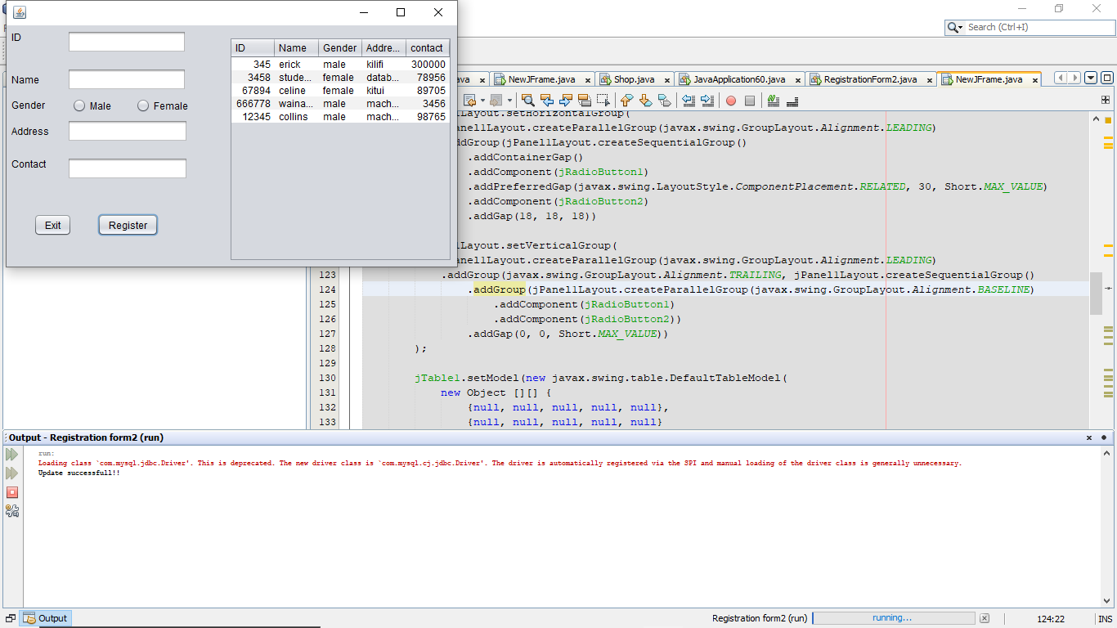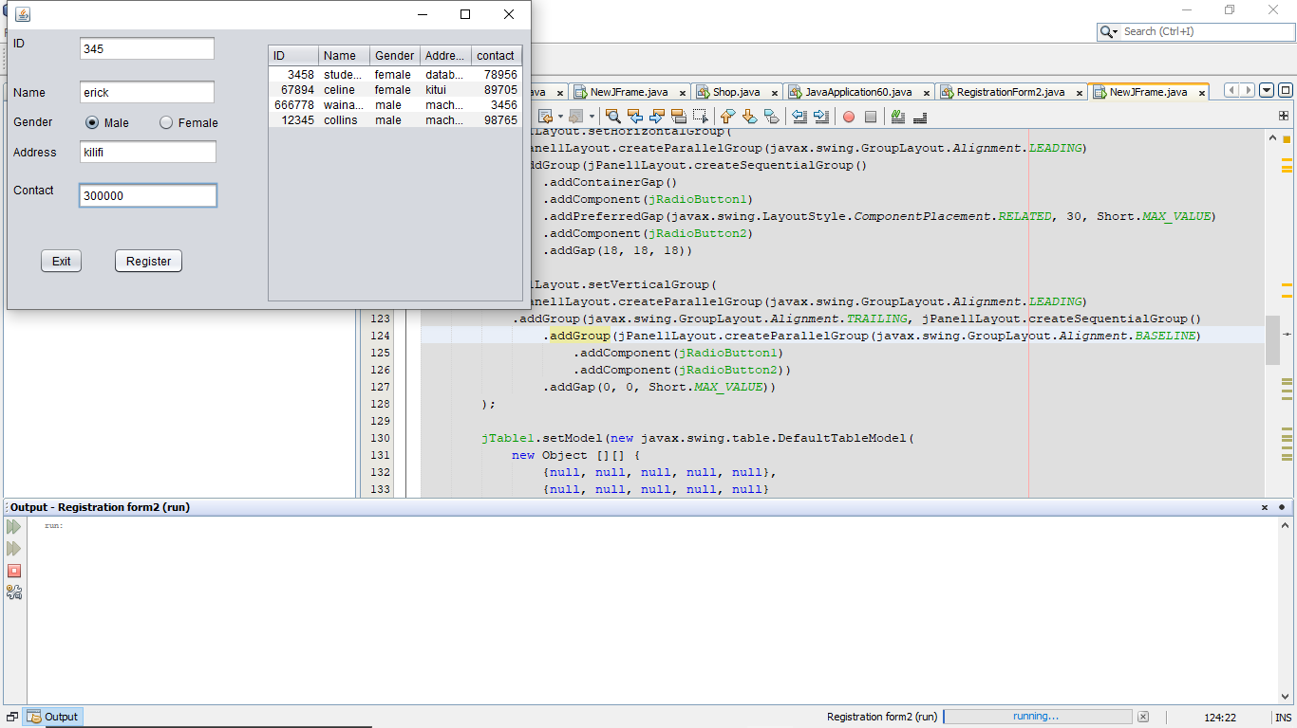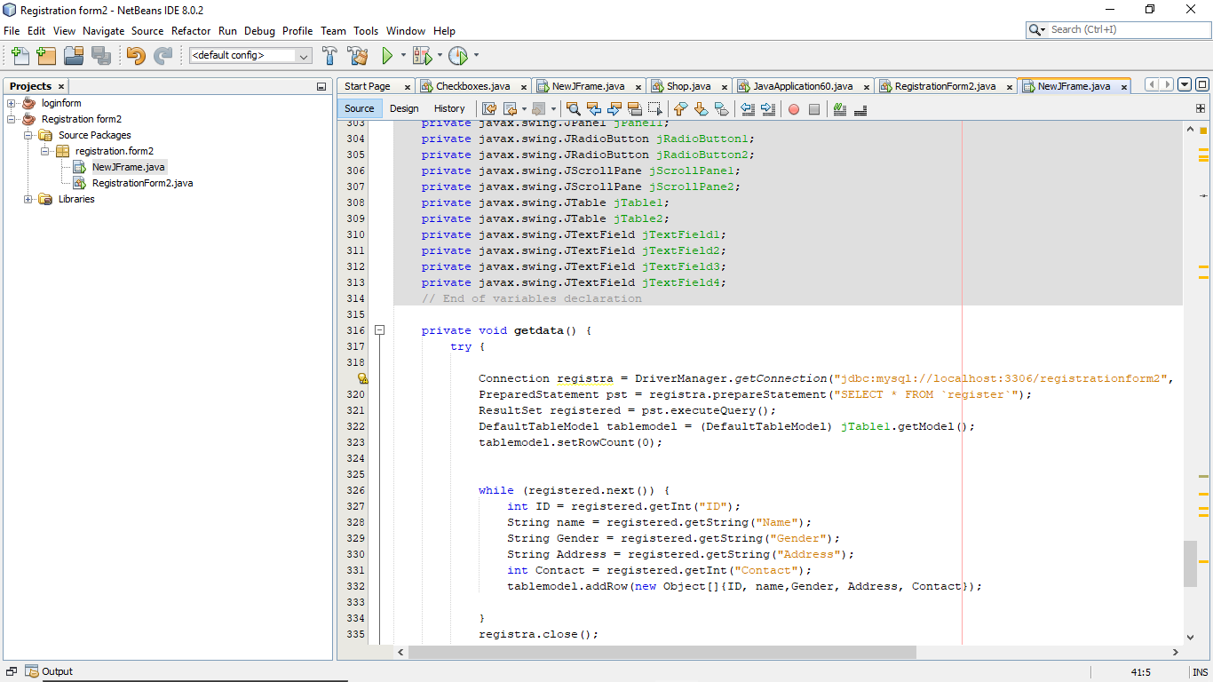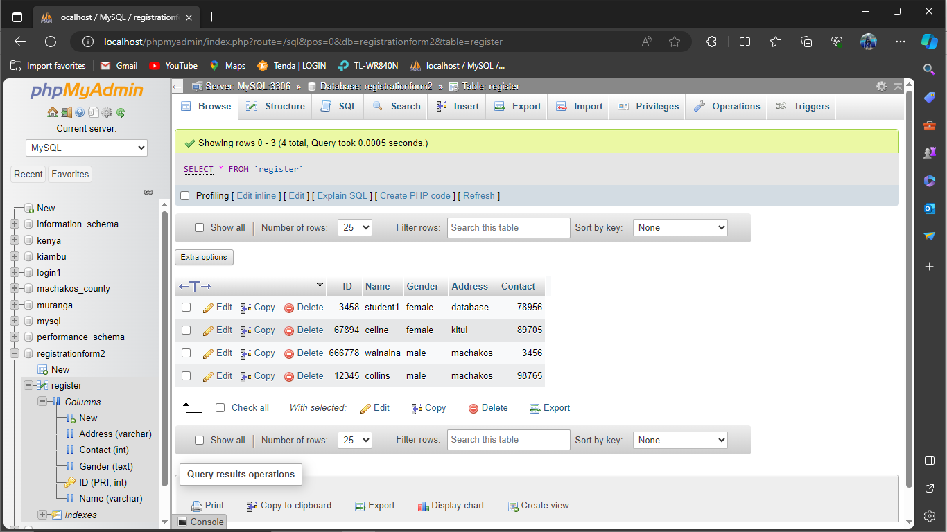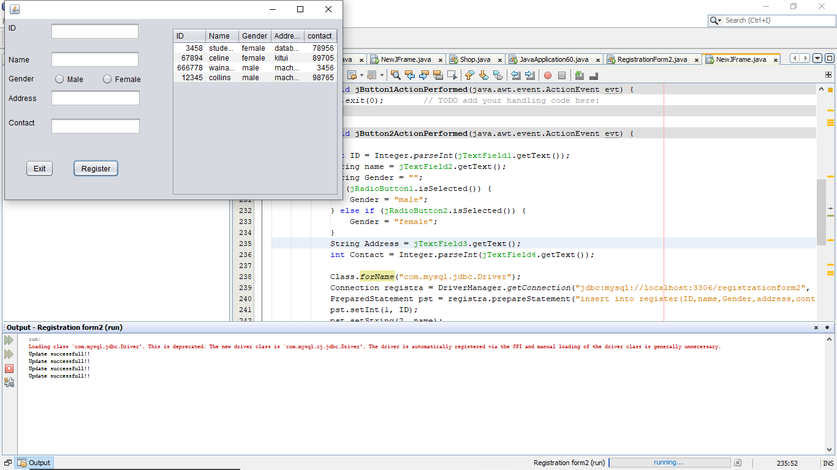

END OF QUESTION 2